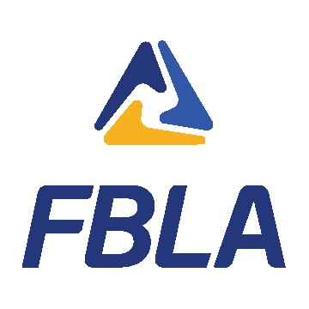 | CUSTOMER SERVICE  SAMPLE ROLE PLAY 2

Disclaimer: This is a sample role play of what a competitor will find in this competition. To view the official guidelines, visit the Competition page of the national website at www.fbla.org.

COMPETITOR INSTRUCTIONS
- You have 20 minutes to review the case.
- Presentation time is seven minutes. At timekeeper will stand and hold up a colored card indicating one minute is left, and at time the timekeeper will stand and hold up a card indicating time is up.
- The presentation is interactive with the judges who will ask questions throughout the presentation. A judge will assume the role of an Expedited Appliance Delivery customer.
- You (competitor) work as a customer care representative for Expedited Appliance Delivery, a regional area delivery company contracted out by one of the large home improvement stores to schedule, deliver, and install appliances.
- You will be given two note cards. Note cards will be collected following the presentation.

PERFORMANCE INDICATORS
- Demonstrate a positive and professional demeanor for client service.
- Explain a cultural sensitivity plan for client service.
- Explain the economics of satisfied clients.
- Separate relevant information from invalid information.
- Describe the ways businesses maintain product and service quality resulting in more client satisfaction.
- Describe characteristics important to the success of client service.

ROLE PLAY SITUATION

Background Information
You are a Customer Care Representative within the Membership Department of the FBLA National Center. You handle all calls related to membership benefits, renewals, and contact information updates. You field an average of 100 calls per day. During each call, you need to verify the caller’s current contact information prior to answering any questions.

Scenario
It is important to be aware of the various levels of FBLA and the benefits provided for each division. Your goal is to update the caller’s contact information, understand their request and needs, and prescribe various options available to them as current and past FBLA members.
The judges are all past FBLA members from different chapters and now work for the same company. During a recent lunch outing, the discussion came up about wanting to volunteer their time and support to local FBLA chapters in their area. You should provide information about the FBLA Alumni Professional Network. You will be fielding a call from a past FBLA member (judges). You should “answer the call” with the following greeting:
“FBLA National Center, this is _______ (your name). How may I help you?”

Other Useful Information
- Communicate the benefits of membership.
- Provide ways to contact state and local chapters.
- Explain the type of opportunities where volunteers are needed such as coaching, judging, mentors, and fundraising.

Things to Consider
You must present strategies/solutions to address the client’s questions during the simulated telephone conversation.
You must address the following in your presentation:
- The scenario and the scope involved.
- Your position and why.
- Effective solutions for meeting the caller’s needs.

